Alu. Tilt Combi chair 2025

*Alu. Combi chair can be adjusted from - 5 to 30 Made of powder-coated aluminum.
*Available with gas or electric tilt.
*Seat, back and the elevating armrests are covered with soft polyurethane.
*The leg supports are height adjustable and can be easily removed.
*Comes standard with bucket with a lid and adjustable headrest
*Available with 24 "wheels

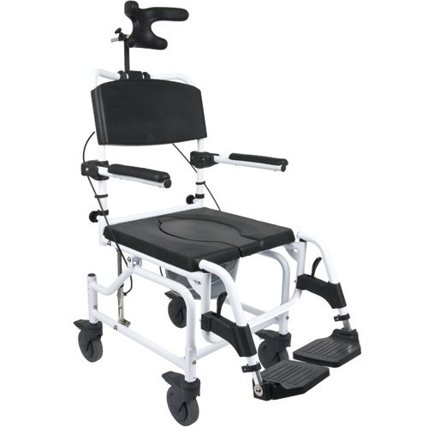

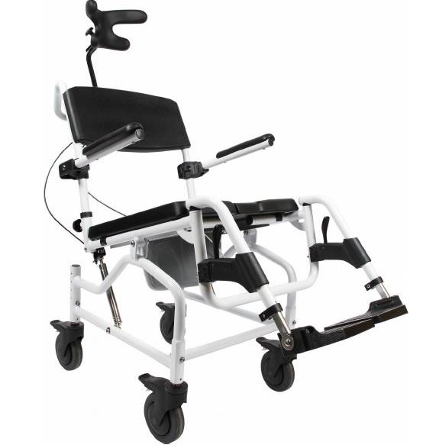

Alu. Combi chair Art No. 2025
HMI: 64256

Technical specification:

Frame: Aluminum powder coated

Seat height: 54-59 cm.

Seat width: 50 cm.

Seat depth: 43 cm.

Max user weight: 150 kg.

Total weight: 16 kg

Back height: 47 cm

Total length: 93 cm.

Total width: 61 cm

Max Outside Toilet Width: ………..…………………. 45 cm

Adjustable height: 90-95 cm.

